**[Marinated Flap Steak](http://feedproxy.google.com/~r/CavegirlCuisine/~3/HNdN332ox0U/?utm_source=feedburner&utm_medium=email)**

Posted: 14 Aug 2014 02:29 PM PDT

Flap steak is basically a sirloin tip. Flank steak or skirt steak is very similar and can be used as substitutions in this recipe.

**[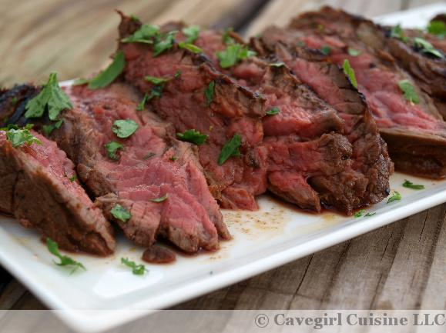](http://cavegirlcuisine.com/wp-content/uploads/2014/08/Marinated-Flap-Steak.jpg)**

### Ingredients

* 1/4 cup red wine vingar
* 1/3 cup avocado oil (or preferred oil)
* 1 tablespoon capers
* 1/2 teaspoon garlic powder
* 1 teaspoon Worcestershire sauce
* 2 teaspoons smoked paprika
* 1/2 teaspoon onion powder
* 1 pound flap steak (or skirt steak or flank steak)
* a handful of chopped parsley (optional garnish)

### Directions

1. In a bowl or a gallon plastic baggie, combine the first seven ingredients.  Mix until combined. Add meat to the marinade.  Refrigerate at least one hour, preferably overnight.
2. Heat a grill or a grilling pan on medium-high heat. Season each side of the beef with fine sea salt. Cook on both sides until desired doneness. Let rest for 5-7 minutes.
3. Thinly slice the meat against the grain and serve. Sprinkle with chopped parsley for optional garnish.
4. Enjoy!